**Python scripts for analysing datasets**

Use Jupyter to open a new ‘doc’

Ideally within the same folder where the dataset is saved

import pandas as pd

df = pd.read_csv('iris_dataset.csv')

df.describe() – prints the data to the screen with

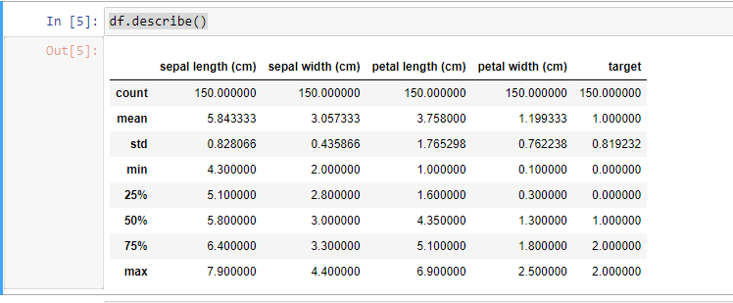

df.corr() correlation co-efficients

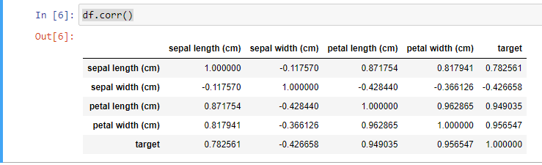

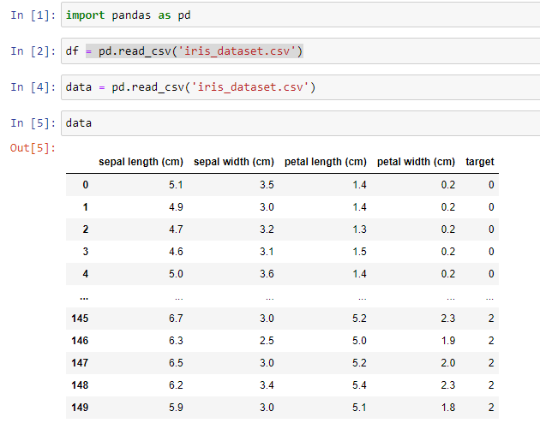

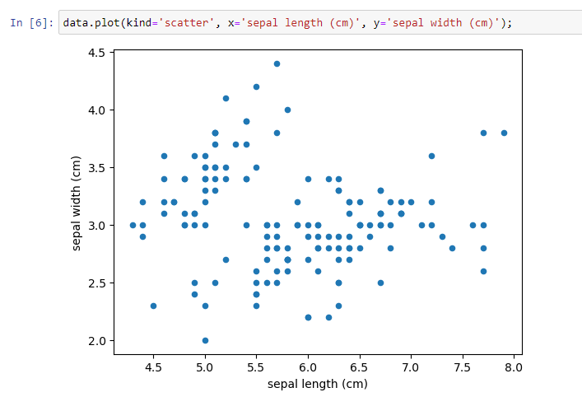

Can vary the x and y axes depending on what you want to analyse

Different types of graph –